Martha Foye, Dave Hiltbrand, and Allen Phelps

Dr. Cuixian Chen

STT 592

9 September 2016

**Section 1: Description of Data**

Our dataset is comprised demographic and psychometric information about a military sample of veterans referred for neuropsychological evaluation out of the naval hospital at Camp Lejeune, North Carolina. Divided into two parts in Section 2, is a subset of the variables, including a brief overview of who the participants are and how we will attempt to measure the validity of their full assessment. In addition to those summarized below, variable demographics include handedness, number of deployments, military rank, time (in months) since last injury, and frequency of lost consciousness. A group variable divides the participants by Post-Traumatic Stress Disorder diagnosis, blast injury, and both or neither of the prior two.

In addition to the Anxious Arousal and Depression scales of the Trauma Symptom Inventory, the dataset includes t-scores for its eight other clinical—Anger/Irritability, Intrusive Experiences, Defensive Avoidance, Dissociation, Sexual Concerns, Dysfunctional Sexual Behavior, Impaired Self-reference, and Tension Reduction Behavior—and three validity scales (Inconsistent Response, Atypical Response, and Response Level). It also includes t-scores for the Minnesota Multiphasic Personality Inventory (MMPI), although the names of its clinical and validity scales do not all give a direct sense of what they measure. For brevity, suffice it to say that the MMPI was designed to measure adult personality and psychopathology, including anxiety and depression, with built-in countermeasures for inconsistency, malingering, and underreporting, which beg comparison to the TSI in particular.

**Section 2: Graphical and Numerical Summary of Variables**

**a. Demographics**

The following graphs and statistics summarize how the 893 participants in our dataset are distributed demographically. In general, they are Caucasian, high school graduates, in their mid-twenties, male, and veterans of Iraq and Afghanistan. Very little variation from this generalization is observed since the sample is comprised of US Marines and sailors for which these distributions are typical of its respective population. Each variable was chosen for both straightforwardness and its ability to convey this information in visual variety.

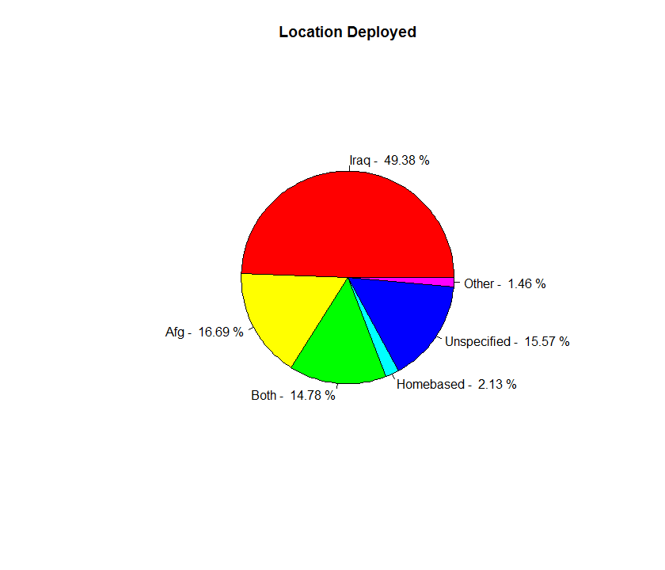

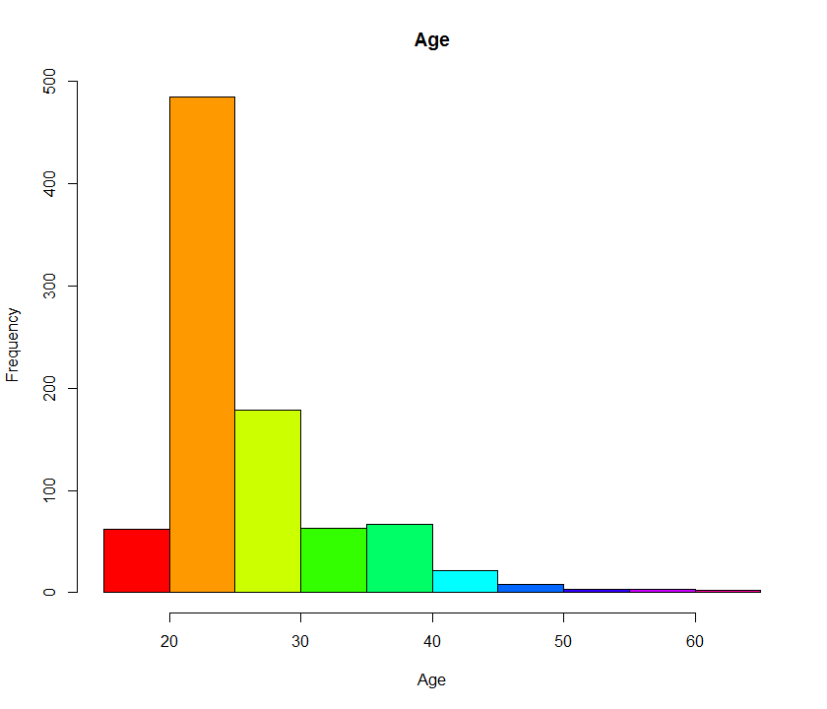

Min. 1st Qu. Median Mean 3rd Qu. Max. SD

18.00 22.00 24.00 26.32 28.00 63.00 6.686574

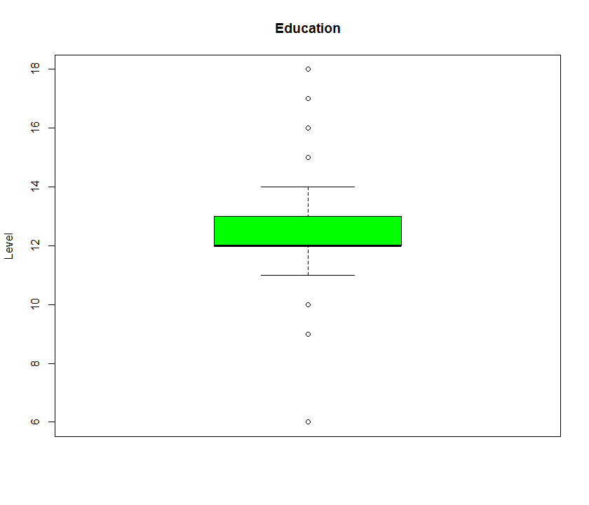

Min. 1st Qu. Median Mean 3rd Qu. Max. SD

6.00 12.00 12.00 12.51 13.00 18.00 1.133208

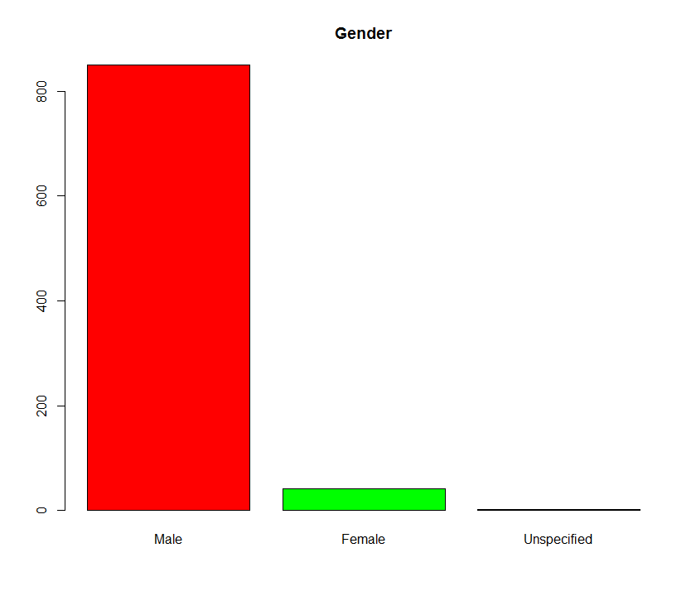

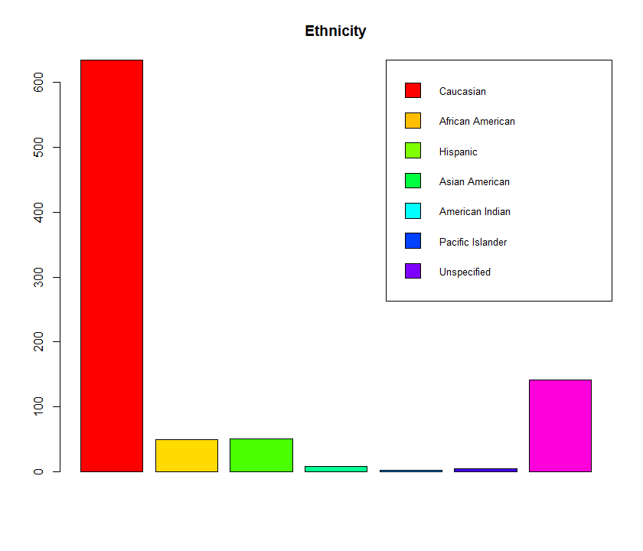

**b. Psychometrics**

The following graphs and statistics summarize participant responses to a substantial battery of psychological testing. Our initial inquiry includes comparison of how similar measures of mental pathology—like anxiety and depression—and validity, such as inconsistency and malingering, are distributed between tests. For example, the distribution of the Test of Memory Malingering (TOMM) is reassuring in that it was designed such that even severely brain damaged individuals should score within the 45-50 range. Contrarily, the lower end of the Beck Anxiety Inventory and Zung Depression Scale (ZDS) distributions present a range problem in that not even the “normal” range of each is as low as many of the observations. Furthermore, the Trauma Symptom Inventory (TSI) Depression (D) t-scores do not appear to have as symmetric of spread as the ZDS levels of depression for two assessments that are supposed to be measuring the same psychopathology. Exploratory data analysis of the like will guide our research further toward the goal of gauging the overall reliability of the dataset.

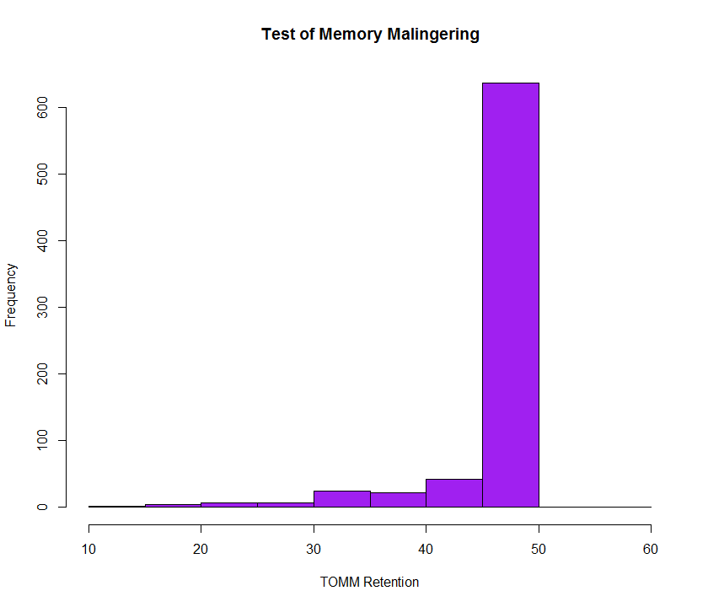

Min. 1st Qu. Median Mean 3rd Qu. Max. SD

12.00 49.00 50.00 47.71 50.00 58.00 5.706588

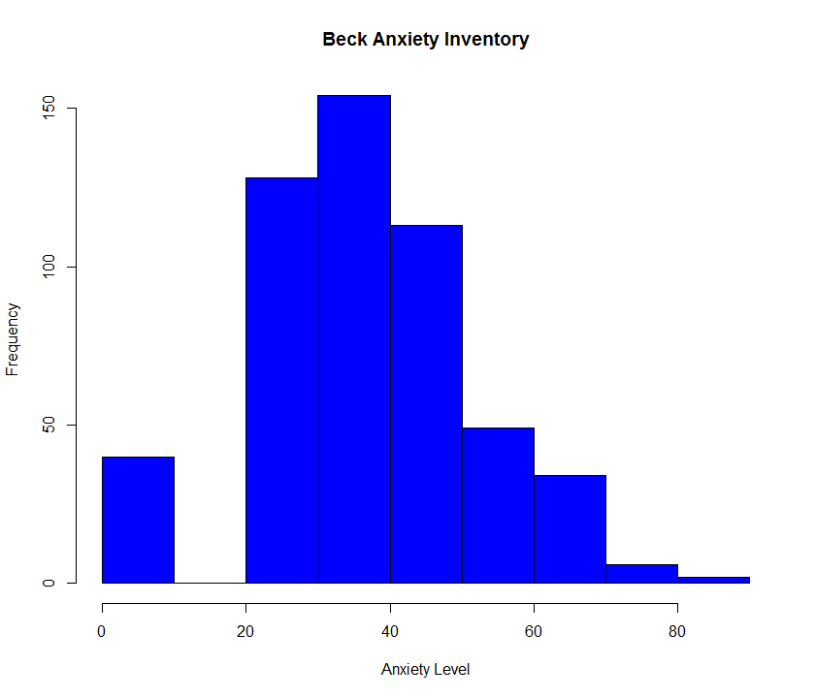

Min. 1st Qu. Median Mean 3rd Qu. Max. SD

3.00 27.00 36.00 36.76 46.00 84.00 15.35003

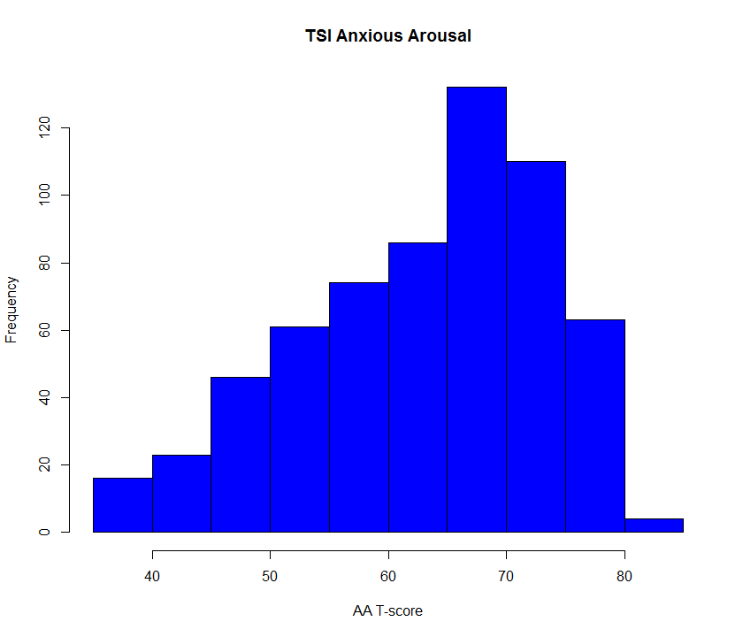

Min. 1st Qu. Median Mean 3rd Qu. Max. SD

38.00 57.00 66.00 63.46 71.00 82.00 10.51869

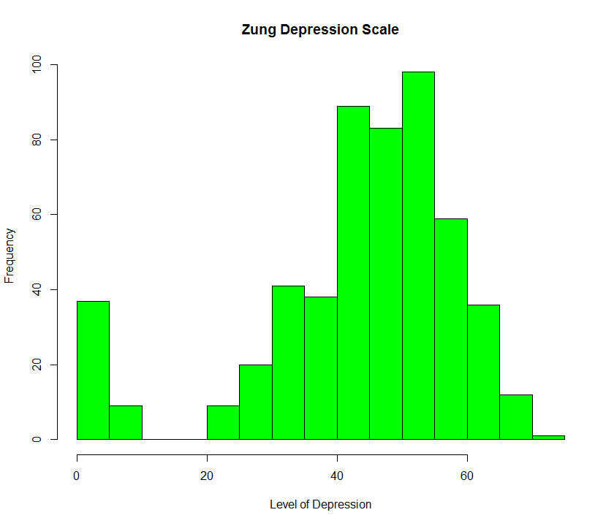

Min. 1st Qu. Median Mean 3rd Qu. Max. SD

2.00 37.00 47.00 43.69 54.00 73.00 15.38974

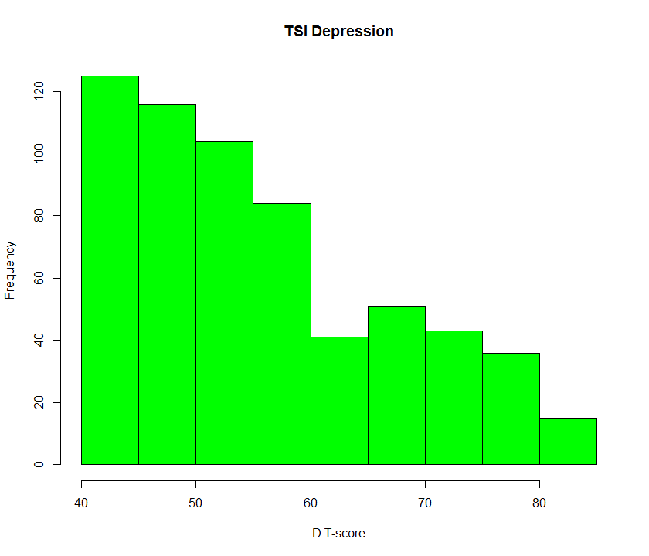

Min. 1st Qu. Median Mean 3rd Qu. Max. SD

41.00 47.00 53.00 56.25 64.00 83.00 11.32396

**Appendix: R Code**

dat=read.csv('stt592dat.csv',header=T)

attach(dat)

names(dat)

ldeployn=c(441,149,132,19,139,13)

slices=ldeployn

labels=c('Iraq - ','Afg - ','Both - ','Homebased - ','Unspecified - ','Other - ')

percent=round(slices/893*100,digits=2)

labels=paste(labels,percent)

labels=paste(labels,'%')

pie(slices,labels=labels,col=rainbow(6),main='Location Deployed')

hist(age,col=rainbow(10),main='Age',xlab='Age')

summary(age);sd(age,na.rm=T)

boxplot(education,col='green',main='Education',ylab='Level')

summary(education);sd(education,na.rm=T)

table(gender)

gendern=c(850,41,2)

barplot(gendern,col=rainbow(3),main='Gender',names.arg=c('Male','Female','Unspecified'))

table(ethnicity)

ethnicityn=c(634,50,51,8,3,5,142)

barplot(ethnicityn,col=rainbow(7),main='Ethnicity')

legend(c('Caucasian','African American','Hispanic','Asian American','American Indian','Pacific Islander','Unspecified'),cex=0.8,fill=c(rainbow(8)),inset=0,x='topright')

hist(retention,col='purple',main='Test of Memory Malingering',xlab='TOMM Retention')

summary(retention);sd(retention,na.rm=T)

hist(bai,col='blue',main='Beck Anxiety Inventory',xlab='Anxiety Level')

summary(bai);sd(bai,na.rm=T)

hist(aa,col='blue',main='TSI Anxious Arousal',xlab='AA T-score')

summary(aa);sd(aa,na.rm=T)

hist(zds,col='green',main='Zung Depression Scale',xlab='Level of Depression')

summary(zds);sd(zds,na.rm=T)

hist(d,col='green',main='TSI Depression',xlab='D T-score')

summary(d);sd(d,na.rm=T)